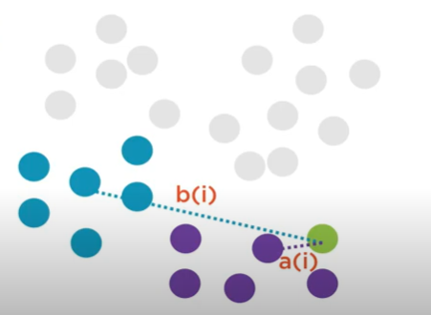**Silhouette score:**



**Steps to find the silhouette coefficient of an i’th point:**

* Compute a(i): The average distance of that point with all other points in the same clusters.
* Compute b(i): The average distance of that point with all the points in the closest cluster to its cluster.
* Compute s(i) — silhouette coefficient or i’th point using below mentioned formula.
* After computing the silhouette coefficient for each point, average it out to get the silhouette score.

The Silhouette coefficient of +1 indicates that the sample is far away from the neighboring clusters.  
The Silhouette coefficient of 0 indicates that the sample is on or very close to the decision boundary between two neighboring clusters.  
Silhouette coefficient <0 indicates that those samples might have been assigned to the wrong cluster or are outliers.